Teacher Notes for "The Ecology of Lyme Disease"

This analysis and discussion activity engages students in understanding the lifecycle and adaptations of black-legged ticks and the relationships between these ticks, their vertebrate hosts, and the bacteria that cause Lyme disease. Students use this background to analyze when and where human risk of Lyme disease is greatest, why rates of Lyme disease have increased in recent decades in the US, and ecological approaches to preventing Lyme disease.

Learning Goals
- Black-legged ticks have one long blood meal during each developmental stage (larva, nymph and adult). During each blood meal, a tick secretes saliva into the host. This saliva contains chemicals that increase blood flow and inhibit blood clotting, pain and itching; these are useful adaptations that help the tick to feed successfully.
- The bacteria that cause Lyme disease live alternately in black-legged ticks and in the mammalian hosts of ticks. A tick becomes infected when blood from an infected host carries the Lyme disease bacteria into the tick’s gut. A mammalian host becomes infected when saliva from an infected tick carries the bacteria into the host's blood. Lyme disease bacteria can move from the tick's gut to the salivary glands, which is a needed adaptation for the continued survival and reproduction of Lyme disease bacteria.
- Understanding the tick lifecycle provides the basis for understanding why Lyme disease risk is greatest in June and July in the northeastern US. Also, Lyme disease risk is greatest in or near forests, which provide a layer of damp decaying leaves where black-legged ticks can avoid drying out during the long periods they spend on the ground.
- In the northeastern US, succession on abandoned farm fields resulted in a substantial increase in forests during the twentieth century. The increase in forests in turn has contributed to an increase in populations of black-legged ticks and an associated increase in human risk of Lyme disease. Increased suburban living near wooded areas has increased human exposure to the bite of infected black-legged ticks.
- Lyme disease bacteria (internal parasites), black-legged ticks (external parasites), white-footed mice (omnivores), shrews (carnivores), herbivorous insects and various plants make up a small part of a forest food web.
- Ecological approaches to preventing Lyme disease attempt to change a biological community in ways that reduce the number of black-legged tick nymphs that are infected with Lyme disease bacteria. Attempts to eliminate white-tailed deer from an area (to reduce reproduction of black-legged ticks) and vaccinate white-footed mice (to reduce the portion of tick nymphs that are infected with Lyme disease bacteria) have had only limited success, in part because there are multiple alternate hosts for tick adults and nymphs. This illustrates the importance of understanding the complex interactions in biological communities in order to develop effective ecological approaches to prevention of Lyme disease.
- Understanding the ecology and behavior of black-legged ticks provides the basis for understanding how a person can reduce his or her risk of Lyme disease.
In accord with the Next Generation Science Standards:
- This activity will help students to meet Performance Expectation HS-LS4-5, "Evaluate the evidence supporting claims that changes in environmental conditions may result in increases in the number of individuals of some species…"
- This activity helps students to understand the Disciplinary Core Idea, LS4.C: Adaptation – "Natural selection leads to adaptation, that is, to a population dominated by organisms that are anatomically, behaviorally and physiologically well suited to survive and reproduce in a specific environment."… "Changes in the physical environment, whether naturally occurring or human induced, have thus contributed to the expansion of some species…."
- In this activity students engage in three scientific practices, interpreting data, constructing explanations and arguing from evidence.
- This activity provides the opportunity for students to learn about the crosscutting concept, stability and change.

Instructional Suggestions and Background Information
As background for this activity, it will be helpful if your students are familiar with:
- interactions in biological communities (e.g. herbivory, predation and parasitism)
- succession (e.g. using the analysis and discussion activity, "Changing Biological Communities – Disturbance and Succession", available at http://serendipstudio.org/exchange/bioactivities/succession).
To maximize student participation and learning, I suggest that, for each page of the Student Handout, you have your students work individually, in pairs, or in small groups to complete the questions and then have a class discussion of student answers to probe their thinking and guide them to a sound understanding of the concepts and information covered in that section of the activity. You may want to try having your students work in groups of four, each with a specific task. One student is the facilitator (responsible for keeping the group on task and time management). Another student is the reader (reads information out loud). Another student is the recorder (records the answers in the Student Handout that the group turns in). The fourth student in each group is the spokesperson (reports out to the class during class discussions).

A key is available upon request to the author (iwaldron@sas.upenn.edu). The following paragraphs provide additional instructional suggestions and background information.

Pages 1-2 of the Student Handout introduce the students to the adaptations and lifecycle of black-legged ticks and the complex interactions between multiple types of organisms that interact to influence human risk of Lyme disease. Students will need this information not only to answer the questions on pages 1-2 of the Student Handout, but also for questions on later pages. You may want to point this out to your students to encourage careful reading, or perhaps you might want to suggest that they should read like detectives who are looking for clues to figure out the Lyme disease mystery.

To increase readability, the Student Handout uses common names rather than the scientific names for the various species mentioned. The table on the next page shows the scientific species names for the most important specific organisms discussed in the Student Handout. If you prefer to use the scientific names instead of or in addition to the common names in the Student Handout, you can easily modify the Word document.

Common Name | Scientific Species Name
Lyme disease bacteria | Borrelia burgdorferi
Black-legged tick (a.k.a. deer tick) | Ixodes scapularis
White-footed mouse | Peromyscus leucopus
Masked shrew | Sorex cinereus
Short-tailed shrew | Blarina brevicauda
White-tailed deer | Odocoileus virginianus
Opossum | Didelphis virginiana
Common raccoon | Procyon lotor

Lyme disease  A person’s body responds to the Lyme disease bacteria with an inflammatory response. This inflammatory response (which evolved as a defense against infection) causes many of the symptoms of Lyme disease. These symptoms usually include a bull's-eye skin rash, aches, fatigue and fever. If the infection is untreated, a prolonged inflammatory response may damage joints (causing arthritis) and may damage the heart and/or brain.  The ecology of Lyme disease varies in different regions of the US. The Student Handout focuses on the ecology of Lyme disease in the Northeast. Approximately three-quarters of reported cases of Lyme disease in the US occur in the Northeast.  For additional information about Lyme disease, see http://www.cdc.gov/lyme/ and http://www.aldf.com/lyme.shtml . | 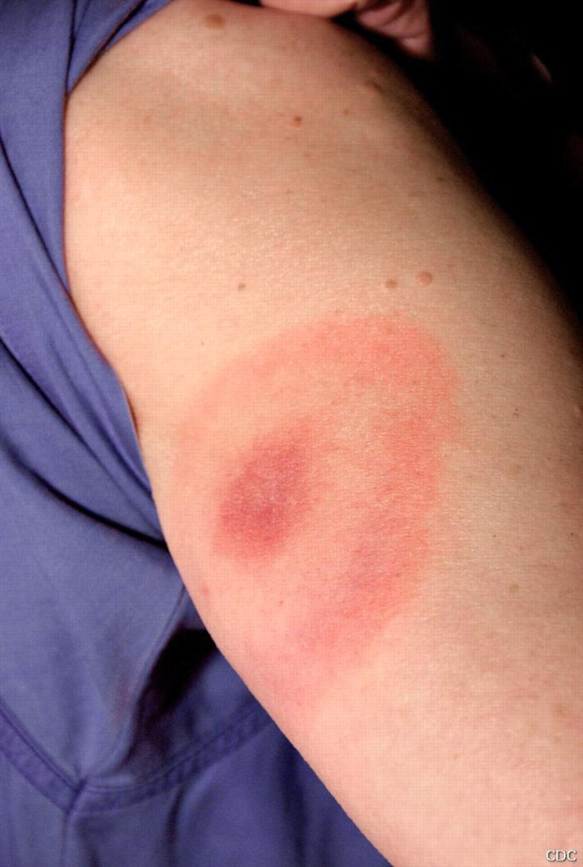
Lyme disease bacteria
Lyme disease bacteria (Borrelia burgdorferi) are endoparasites (internal parasites). In discussing the bottom of page 1 of the Student Handout, you may want to contrast the transmission of Lyme disease bacteria back and forth between tick and vertebrate hosts with the more familiar transmission of some bacteria and viruses from human to human (e.g. cold and flu viruses). Although Lyme disease bacteria infect black-legged ticks and white-footed mice, this does not appear to cause illness.

The figure on the last page of these Teacher Notes shows the structure of these spirochete bacteria, including the flagella which provide the basis for motility. As discussed in question 5 in the Student Handout, one important adaptation of Lyme disease bacteria is the ability to move from a tick’s gut to its salivary glands when the tick starts to feed. Question 5b provides the opportunity to discuss how this adaptation would be favored by the process of natural selection. If you discuss natural selection, you may want to include discussion of natural selection for the adaptations of the black-legged tick presented in question 1 of the Student Handout. You may also want to discuss the generalization that all parasites have to evolve some way of transferring from one host to another.

Black-legged ticks
Black-legged ticks (Ixodes scapularis) are ectoparasites (external parasites). These ticks have multiple adaptations that increase their success in obtaining a large blood meal during each feeding:
- Chemicals in tick saliva inhibit blood clotting and increase blood flow; this results in greater availability of blood for the tick to consume.
- Chemicals in tick saliva also inhibit pain and itching (in part by inhibiting the inflammatory response); this reduces the likelihood that a tick bite will be detected by the host which could kill the tick or brush it off during the prolonged tick meal.
- A feeding black-legged tick secretes a cement-like substance that works with the backward pointing barbs on the mouthparts to hold a tick in place during the prolonged feeding session (2.5-8 days for larvae and nymphs and 5-12 days for adults).

A black-legged tick can take in a remarkable amount of blood during each meal. A fully fed adult female may weigh ~100 times its pre-meal weight. She has actually taken in at least twice that amount of blood and secreted excess water from the blood meal to her saliva and back into the host. During the prolonged blood meal, relatively little blood is taken in during the first few days, with most of the intake during the last day. This postpones the substantial increase in size to the end of the blood meal; this may be an adaptation to reduce the likelihood of detection during the long blood meal.

Before a tick begins to feed, Lyme disease bacteria are found mainly in the tick midgut. During the early days of a blood meal, Lyme disease bacteria migrate from the midgut to the salivary glands. Because there are few Lyme disease bacteria in a tick’s saliva during the first day or two of feeding, the risk of infection is low if a tick is detected and removed promptly.

It is believed that the main reasons why most cases of Lyme disease are due to the bite of a tick nymph are:
- Adult ticks are large enough that they are more easily detected than nymphs so they often are removed before they can cause an infection.
- Larvae only become infected with Lyme disease bacteria after they have taken their single blood meal.
The close relationship between the season of tick nymph feeding activity and the onset of human Lyme disease cases shown in question 4 in the Student Handout suggests that most cases are diagnosed relatively soon after a tick bite.

One reason why Lyme disease risk is particularly high in the northeastern US is that in this region nymphs feed earlier each year than larvae feed, so the bite of an infected tick nymph can infect white-footed mice or other small mammals early enough in the year that these small mammals can in turn infect the tick larvae of the next cohort.

In addition to being the vector for Lyme disease bacteria, black-legged ticks can also be the vector for another disease-causing bacterium (Anaplasma phagocytophilum) and a disease-causing protist (Babesia microti). However, Lyme disease is much more common than either of the latter. Indeed, Lyme disease is by far the most common illness transmitted by any arthropod in the US.

A good source of additional information about ticks is available in "Dirty Secrets of Bloodthirsty Ticks" (http://www.nytimes.com/2000/07/11/science/dirty-secrets-of-bloodthirsty-ticks.html?pagewanted=2 ).

Forest Ecosystems, Lyme Disease Trends and Prevention
The Pleistocene ice sheet eliminated tick populations in most of the area that is now the northern US. These areas have been repopulated with black-legged ticks that originally dispersed from southern populations and then spread through increasing areas of the Northeast and upper Midwest. Ticks have quite limited mobility, so geographic spread of tick populations is largely due to travel of host mammals and birds that are carrying feeding ticks. The rate of spread has been limited by the rate of travel of these host animals and the availability of suitable habitat for the ticks and their hosts.

Since black-legged ticks thrive in a forest habitat with relatively abundant, moist leaf litter, the increase in forests in the Northeast during the twentieth century has increased the amount of habitat available for these ticks. A major cause of the increase in forests has been succession in abandoned farm fields. In the early stages of succession after an agricultural field has been abandoned, the dominant plants in a biological community are rapidly growing plants that have seeds that readily disperse over substantial distances (in addition to persistent weeds and crop plants). Large, long-lived plants that are good competitors for light and water become more abundant in the later stages of succession. Thus, over a period of decades, trees become the dominant plants (assuming there is sufficient rainfall and not too much fire or herbivory). This illustrates how a biological community that appears stable over the short-term can change dramatically when observed over the long-term. Additional information is provided in our analysis and discussion activity, "Changing Biological Communities – Disturbance and Succession" (available at http://serendipstudio.org/exchange/bioactivities/succession).

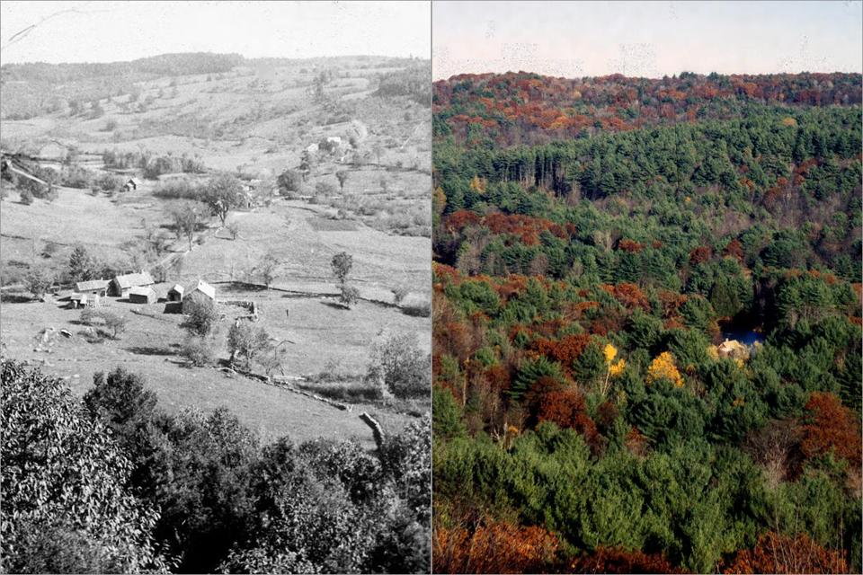
This pair of photos of the Swift River Valley in Massachusetts in the 1880s and in 2010 shows a dramatic example of the results of succession in abandoned farm fields in the Northeast. (http://lancemannion.typepad.com/.a/6a00d83451be5969e2019aff43d581970d-pi )

The following table shows general trends of disturbance and succession in the northeastern US. Notice that human disturbance not only affects the overall biological community, but can also have specific effects on a particular type of animal in the biological community (e.g. white-tailed deer).
17th-19th centuries (Human disturbance) | 20th century
Percent of land covered with forests decreased from well over 75% to less than 25% due to land cleared for farms and logging for timber and firewood. | Forests increased due to succession after farm fields were abandoned (now ~75% forest).
White-tailed deer population decreased by ~90% due to hunting for meat and hides and decreased forests. | White-tailed deer population increased ~10-fold due to restrictions on hunting and regrowth of forests.

White-tailed deer eat a wide variety of plant foods, including green vegetation and grains from fields in the summer, acorns and other nuts in the fall, and buds and twigs in the winter. Deer use thickets for hiding from predators (currently humans; previously wolves and large cats such as mountain lions or bobcats). Thus, white-tailed deer thrive in regions that have diverse vegetation, including forests, shrubs and fields. This type of edge habitat is relatively common in some suburbs. For many suburban homes, black-legged ticks spread from forested areas to nearby lawns and ornamental plantings.

Another factor that appears to have contributed to the northward extension of the range of black-legged ticks is global warming and the associated milder winters. (Reports of the Intergovernmental Panel on Climate Change are available at http://ipcc.ch/.)

Trends in Lyme disease cases
Lyme disease was first identified in the US in 1975 when an investigation of a cluster of children with arthritis in Lyme, Connecticut identified the cause of the arthritis as Lyme disease. Subsequent research established that there had been earlier cases which had not been identified when they occurred. However, it appears that Lyme disease was relatively uncommon before the 1970s and Lyme disease was recognized in 1975 in part because it was becoming more common. Since 1975 there has been an overall trend to increased number of cases as well as a geographic expansion of reported Lyme disease cases.
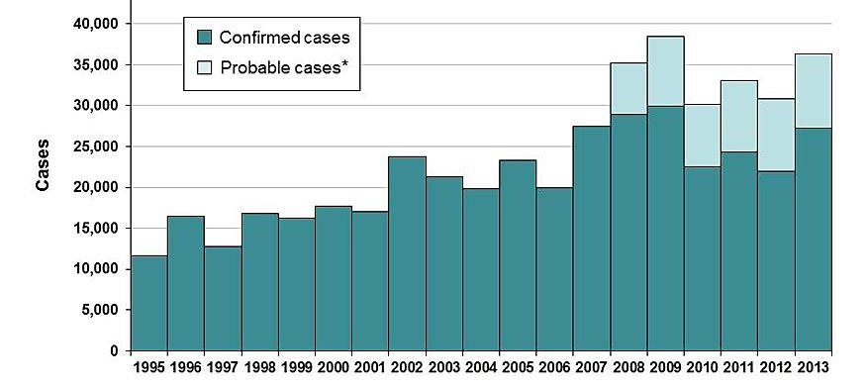
(http://www.cdc.gov/lyme/images/statstables/Casenumbersgraph1995_2013.jpg)

Testing of blood samples indicates that the annual number of people infected with Lyme disease bacteria is roughly 10 times the number of reported cases (~300,000 vs. 30,000). There are several reasons for this substantial discrepancy. Some people with Lyme disease bacteria infections do not develop symptoms, some people who develop symptoms do not seek medical help, and some doctors may fail to report all Lyme disease cases. The difficulty of accurately assessing the number of Lyme disease cases is further exacerbated by the likelihood of some overdiagnosis and the possibility of false positives in the blood test for infection by Lyme disease bacteria.

Some of the increase in number of reported cases of Lyme disease (especially in the earlier decades) was due to increased awareness and recognition of Lyme disease. However, careful research studies have confirmed not only an increase in numbers of Lyme disease cases, but also an expansion in geographic range of Lyme disease, e.g. spreading northward from an initial focus in Long Island and southeastern Connecticut along the Hudson River Valley, with recent expansion to the Thousand Islands (along the US-Canada border) and parts of Canada. The geographic spread of populations of Lyme disease bacteria has roughly paralleled the geographic spread of populations of black-legged ticks. Thus, it is not surprising that the geographic spread of human cases of Lyme disease roughly parallels the geographic spread of black-legged ticks. (In the endemic Northeast, ~5-25% of black-legged tick nymphs are infected with Lyme disease bacteria, and ~20-80% of adult ticks are infected.)

Annual rates of Lyme disease cases range as high as ~4-15 cases per 1000 people in some counties, and statewide rates range as high as 0.5-1.0 cases per 1000 people. You may want to point out to your students that, even in areas with high risk of Lyme disease, the vast majority of people do not develop Lyme disease in any given year. Obviously, cumulative risk over multiple years will be higher. For example, one careful study of a high risk community found that, over two decades, 16% of the population had developed symptomatic Lyme disease and an additional 8% had antibody evidence of asymptomatic infection with Lyme disease bacteria.

Ecological Approaches to Preventing Lyme Disease
Questions 9-11 in the Student Handout develop the theme that human risk of Lyme disease is influenced by complex interactions between multiple members of a biological community.

It should be mentioned that the part of the food web shown in question 9 has been substantially simplified. For example, masked shrews eat not only insects, but also spiders, centipedes, slugs and snails, and short-tailed shrews eat not only insects, but also earthworms, millipedes, spiders, small vertebrates and seeds. It should also be noted that, across their range, black-legged ticks feed on more than 50 species of mammals, ~60 species of birds, and 8 species of reptiles. These various hosts differ in the extent to which they transmit Lyme disease bacteria; for example white-footed mice are efficient transmitters of infection with Lyme disease bacteria, but white-tailed deer are ineffective as transmitters of infection with Lyme disease bacteria.

Vaccination of white-footed mice so the mice become immune to infection with Lyme disease bacteria reduces the likelihood that a black-legged tick larva will feed on an infected host. This has been shown to reduce the percent of tick nymphs infected with Lyme disease bacteria. The effectiveness of this approach is limited by the availability of alternative hosts for tick larvae and nymphs. For example, one study found that only about a quarter of infected black-legged tick nymphs had fed on white-footed mice, about half had fed on shrews, about 10% had fed on chipmunks, and another 10% had fed on a variety of other mammals or birds. One way to increase the effectiveness of vaccinating white-footed mice is to repeat vaccination over multiple years; there is a cumulative effect of a decreased proportion of infected nymphs resulting in a decreased proportion of infected hosts resulting in fewer larvae becoming infected. (This is somewhat similar to the herd immunity that result from high rates of vaccinations in humans). Another way to increase the effectiveness of vaccination campaigns in preventing Lyme disease would be to vaccinate additional hosts that transmit Lyme disease bacteria to tick larvae. (No human vaccine is currently available; the company that developed a human vaccine abandoned the vaccine due to concerns about possible harmful long-term effects and low sales.)

Studies of the relationship between numbers of white-tailed deer and black-legged ticks have found inconsistent results. However, experimental and observational studies have found that elimination of deer or reduction of deer populations to extremely low levels is associated with reduced populations of black-legged tick larvae and nymphs. For example, one research study on Long Island compared thirteen wooded areas that had white-tailed deer vs. nine wooded areas that had no deer. The researchers found that the areas with deer had more than 10 times as many nymphs of black-legged ticks; they also found more cases of human Lyme disease in the towns surrounding the areas with deer. To understand why elimination or extremely low numbers of white-tailed deer are associated with reduced populations of black-legged tick nymphs and larvae, but not elimination of ticks, it is helpful to remember that:
- White-tailed deer are important hosts for feeding and mating of adult black-legged ticks. (This explains why black-legged ticks used to be called deer ticks.)
- However, adult black-legged ticks can also feed on other mammals such as raccoons and opossums (as shown in the table and figure on page 2 of the Student Handout).
It should be mentioned that elimination of deer from an area is rarely feasible, so this is not a practical approach to prevention of Lyme disease. Another problem with this approach is that when deer populations are first reduced, there is an increase in the number of tick adults seeking blood meals which increases the risk of tick bites for humans.

As described in question 12 of the Student Handout, a black-legged tick that is seeking a blood meal climbs a foot or two up a plant and waits for a potential host to come close enough for the tick to grab on (ticks do not jump or fly). When a tick detects vibration, carbon dioxide and/or warmth, it waves its front legs to make contact and attach to a host.  In most communities, the responsibility for avoiding Lyme disease rests largely with individuals. An understanding of tick ecology, behavior and physiology can help students to understand the reasons for the recommended practices to reduce Lyme disease risk. Good sources of recommendations for prevention are:  http://www.cdc.gov/Features/LymeDisease/  http://www.cdc.gov/lyme/prev/on_people.html  http://www.cdc.gov/lyme/prev/on_pets.html  http://www.cdc.gov/lyme/prev/in_the_yard.html | 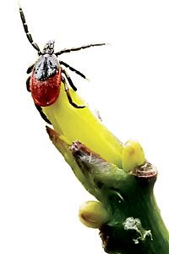  A black-legged tick seeking a host

Other Resources for Students to Learn about Emerging Diseases
Emerging and Re-emerging Infectious Diseases
http://science.education.nih.gov/supplements/nih1/Diseases/default.htm

Ebola Outbreak-Lesson Plan
http://www.pbs.org/newshour/extra/lessons_plans/ebola-outbreak-lesson-plan/
with additional information available at:
http://www.nature.com/news/the-ebola-questions-1.16243
http://www.nature.com/news/ebola-by-the-numbers-the-size-spread-and-cost-of-an-outbreak-1.16144

Structure of Lyme disease bacteria (Borrelia burgdorferi)

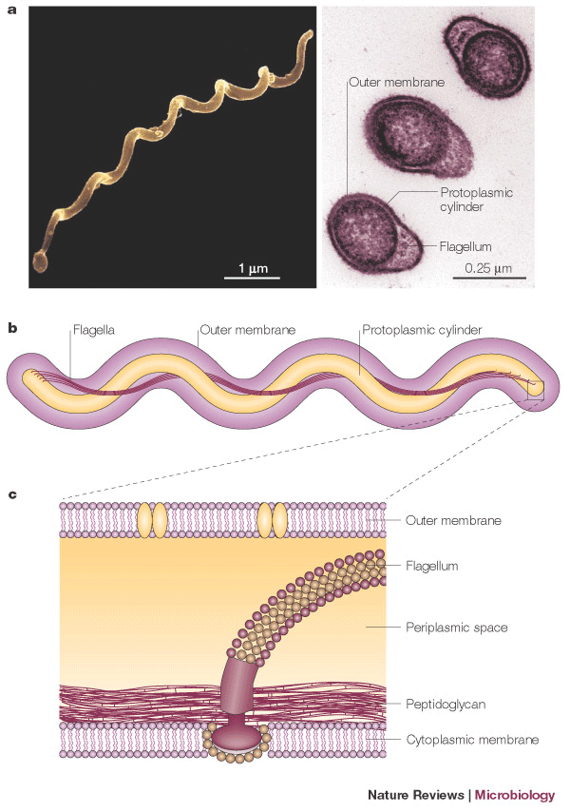
Each spirochete bacterium has multiple flagella which provide the basis for their motility.
(http://www.nature.com/nrmicro/journal/v3/n2/images/nrmicro1086-f1.gif)

By Dr. Ingrid Waldron, Dept. Biology, University of Pennsylvania, © 2015. These Teacher Notes and the related Student Handout are available at http://serendipstudio.org/exchange/bioactivities/LymeDisease
http://www.nextgenscience.org/next-generation-science-standards
I am grateful to Ben Cooper for suggesting this approach which is modified from POGIL (Process-Oriented Guided Inquiry Learning; https://pogil.org/about). I welcome any feedback about how this approach has worked in your classroom.

